Spring 2026 Edition
Mystic Fest
Hosted by Galactic Expo

Date: Saturday & Sunday May 30 & 31, 2026

Place: Mid-America Center
1 Arena Way. Council Bluffs, IA 51501

The purpose of this festival is to provide a forum for the free exchange of ideas for people on all spiritual paths, to enhance group and individual spiritual growth and well-being, and to encourage local support and awareness of available products and services.

A table and chairs will be provided for each booth. Exhibitors must provide their own signs and electrical cords as needed.
This fair does not use pipe & drape. If you are a healer or reader and feel like you need more privacy, feel free to bring a back drop or partition.

10-foot booth space: $240 for one vendor. Two exhibitors may share a booth. The cost for each vendor sharing a booth will be $135. Each vendor must register on a separate form and submit a separate check or money order. No more than two exhibitors per booth will be allowed.

No refunds will be given after April 29, 2026.

NOTE: We do not allow readings at what are reserved as vending booths, and conversely, will only allow a few items, such as decks or books, to be sold on reader or energy-work designated booths. We are doing this to encourage everyone to specialize in what they do best and allow everyone to have a very successful, profitable Mystic Fest. Feel free to contact us with any questions about this rule.

Electrical hookups are $50. Electricity must be requested and paid for at the time of reservation. If you plug in electrical devices to another vendor’s outlet, or extension cord, you will be required to pay the $50 hookup fee.

Please keep pages 1-5, and the table layout for your reference. Please complete and return pages 7-9. If we do not have your paperwork, you definitely do NOT have a table.

SHOW RULES

Please list any and all items you intend to display for sale on your table application form. If it is NOT on your application, you might be asked to remove it from your table. This helps to prevent having multiple tables all selling the same items. We noticed a LOT of booths included a small selection of rocks that Charlie mentioned, weren’t mentioned on the booth description.
The booth is made available to the who submits the application. You cannot sublease the space, even without compensation, to anyone else. Please ask us prior to the Mystic Fest if you have any questions about this rule or its application.

NO burning of sage, or incense or lit candles before or during the show. The venue has cracked down on this. Should you need to smudge your area, we recommend spray smudge.

No outside alcohol, CBD oil, or drugs are allowed on the premises. There is no smoking in the exhibit hall, hallways, or restrooms. Again, please show some courtesy and respect for our non-smoking vendors. Anyone caught violating these rules will be removed from the show. Smoking is allowed outside near the load in/out area.

Please move your vehicle to the North parking lot after unloading. Do not leave it sitting in the street, or parked in the driveway. If you cannot, or will not, comply with this rule, there is a very good chance your vehicle will be towed by the Council Bluffs police department.
Children under the age of 13 will not be allowed to work or hang out in your booths during open hours.
We will have VENDOR badges for you to wear during the event. All vendors must wear their vendor badge at all times during the Mystic Fest.
You are responsible for paying any applicable Iowa sales tax to the state.

Booth operators will NOT tear down early. The people who put forth the effort to join us deserve to see a complete Mystic Fest…not a fragmented one. An announcement will be made at the end of each day that the festival is completed for that day.

Mystic Fest personnel may be available to watch your booth should you need to take a break. In the event we do occupy your booth as a favor to you, we will NOT sell anything, nor handle ANY money for you; we are there strictly as loss prevention.

Security will be posted in the event area overnight from Friday setup through Sunday closing. Please ensure you take everything (purses, cell phones, medicine, etc.) with you that you may need overnight. To safeguard everyone’s booth and personal property, nobody will be allowed to re-enter until 7:00 a.m. Saturday, and 10:00 a.m. Sunday.

The Mid-America Center does not allow any outside food or drink to be brought into the facility. Mid-America Center reserves the right to bill you, at their food rates, if you are caught with any outside food or drink. All people entering the building will be subject to a search of their bags. By completing this application, you agree to be personally liable for any and all charges incurred by you. There will be concession stands available with food and drink for purchase throughout the weekend.
NEW: There will be a hot lunch option on Saturday & Sunday. These meals will be served between 2:00 – 3:00 pm each day. Just mark how many you want each day, and add $20.00 per meal to your fees. It includes the entrée, seasonal sauteed veggies, some type of potato, bottled water and a cookie.
Let us know if you would be willing to offer a door prize as well. We’ll go around and ask during set up. The door prize winner will bring a card to your booth to collect; that way they can actually see what you are offering. Readers & healers, this can be a shortened mini-session.
There is free unsecured wi-fi throughout the venue and the metro.

MYSTIC FEST
hosted by Galactic Expo
thegalacticexpo@gmail.com
816-699-0299
www.mysticfest.net

January 15, 2026

To Potential Exhibitors and Interested Parties:

We hope you had a great time at the Autumn 2025 Mystic Fest! We sure did! As the new show hosts we are excited to get together with everyone and celebrate the spirituality which unites us! Mystic Fest Spring 2026 promises to be better than ever. This festival is a metaphysical gathering focusing upon the different spiritualities that made the past festivals such enjoyable events.

Mystic Fest Spring 2026 will be held at the Mid-America Center located at 1 Arena Way in Council Bluffs, Iowa on Saturday & Sunday, May 30th and 31st. The show hours will be from 10:00 a.m. to 8:00 p.m. Saturday, and 11:00 a.m. to 5:00 p.m. Sunday. Exhibitor set-up time will be Friday, May 29th from 3:00 p.m. until 8:00 p.m., and from 7:00 a.m. to 9:15 a.m. Saturday. All setup must be completed prior to the doors opening to the public. NO exhibitors will be allowed to set up after this time. To not inconvenience other vendors, this policy will be strictly enforced. Booth prices and registration are enclosed for your convenience.

We will be advertising via billboards, television, internet, social media, and flyers in many fine local retail establishments. We strongly encourage you to help promote the Mystic Fest via your social media and e-mails. The more people we attract, the more we all prosper. There is our Private Facebook group where we will post event links. fliers, videos and such that you can share. Search for…Mystic Fest by Galactic Expo VENDOR group

Each full booth is assigned a table and 2 chairs. Those sharing a booth will also share the assigned table. Obviously, you can bring your own tables. Again, if you choose to read and vend outside of just decks/books, that will be a split booth.
NEW: If you wish to offer a free 45-50 minute lecture, gallery, meditation, etc, there is a space to include that in the directory info. At the time we assign booths, we will let you know if your lecture has been accepted and what time it will be.
*****VERY IMPORTANT*****
The Mid-America Center has asked us to share the following information with you. They do NOT allow animals, other than service animals, to be brought into the venue. They also will not allow any open flames or burning of sage, incense, etc at any time. As with the outside food rule…these are not our rules, but it will be enforced by Mid-America Center employees

If you have any questions, please feel free to call Gigi & Sylvia at 816-699-0299 or email us at thegalacticexpo@gmail.com . Please share this weekend of fellowship and enlightenment with us. We are VERY excited to host this event and work with all of you.
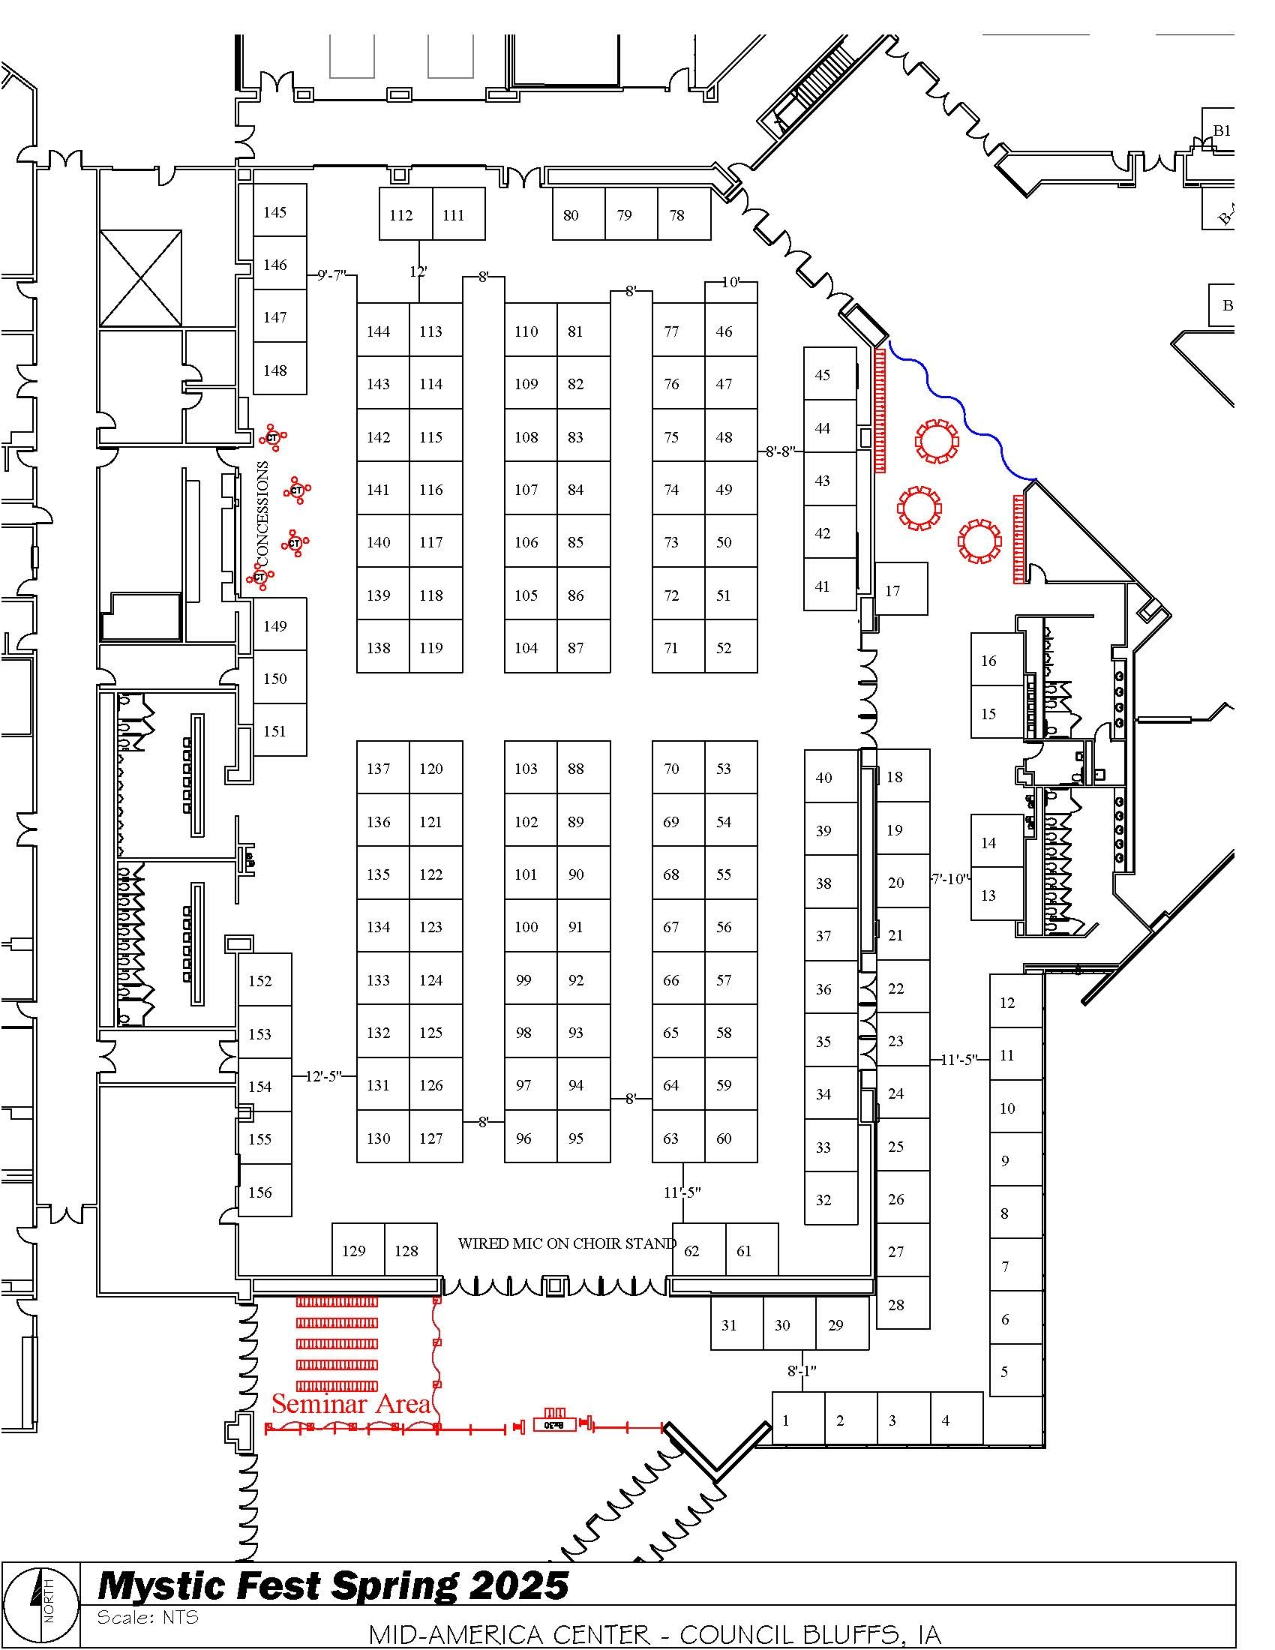

MYSTIC FEST BOOTH REQUEST FORM
(PLEASE NOTE BOOTH SPACES ARE 10 FEET x 10 FEET)

Name: _______________________________________________________
EMAIL: ______________________________________________________

Address: _________________ City: ___________ State: _____ Zip: ______

Daytime Phone: ________________ Evening Phone: __________________

Business Name: ________________________________________________
Website or social media: _________________________________________

My table will be for: Readings _____ Energy Work _____ Vendor _____

One Vendor/One Booth/One Table $240.00 each _______________

Two Vendors/One Booth/One Table $135.00 each __________

Electrical Hookup $50 __________
Meals:
Saturday: meatloaf $20 each. How many? ____ __________
Sunday: smothered chicken $20 each. How many? ____ __________
Extra tables: 8’ _____ 6’ ______ $25 each __________

Total Submitted: __________

I would share a booth with: ________________ Phone: ________________

Included table: 8 foot table ______ 6 foot table ______ No Table ______

Special Needs or Requests: _______________________________________
I will offer a door prize: YES NO
*****This is a request form & MUST accompany your payment. Acceptance of this form does not guarantee you will be assigned a booth. *****

NEW: Please make checks payable to: Galactic - KCM
Mail to: Mystic Fest / Galactic
1221 W 103rd St. #173
Kansas City, MO 64114
You will get an email acknowledging we got your application. Booth assignments will be made approximately 6 weeks before the fair,
Payment will be processed at the time you are ACCEPTED. We will send an email letting you know you are accepted, and that we will be depositing your check.

DIRECTORY INFORMATION
We would like each participant to explain a little bit about the service or product they provide. This information may be included in a directory to be listed online. Please write accurately and legibly, as many people will refer to this directory when seeking goods or services in the coming months. While everything may not be printed in the online directory, much of the information that you provide will be used.
DO NOT list information on this sheet that you do not want made public!

Name: _______________________________________________________

Business Name: ________________________________________________

Address: ______________________________________________________

City: ________________________ State: _________ Zip: ______________

Daytime Phone: ________________ E-Mail Address: _________________

Are you active on social media? _________

No option to use previous directory info this time. There will be next time.

Personal Profile: (Please tell us a little bit about yourself) _______________
___________________________________________________________
_____________________________________________________________
_____________________________________________________________
_____________________________________________________________
_____________________________________________________________

Product or Service Provided: (Please include fees charged) ______________
_____________________________________________________________
_____________________________________________________________
_____________________________________________________________
_____________________________________________________________
_____________________________________________________________
_____________________________________________________________
We reserve the right to edit or omit any information provided.
IF YOU WANT TO OFFER A FREE 45-50 minute LECTURE fill out the following
Lecture Title ____________________________________________________________
Short lecture description ________________________________________________________________________________________________________________________________________________________________________________________________________________________

Returning Vendors receive preference, but NOT a guarantee, if your application is received before February 28, 2026. After that, we may begin to assign booths at any time, even to non-returning vendors. Please submit early to avoid disappointment.

